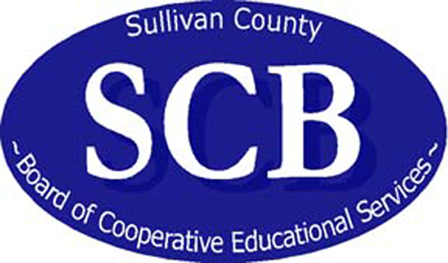

Sullivan County Board of Cooperative Education Services
6 Wierk Avenue Liberty, New York 12754 Tel. (845) 295-4000 Fax (845) 292-8694
.
.
.

School lunch to change this fall thanks to new national nutritional standards
Menus will feature fruits and vegetables every day plus whole-grain rich foods
Students should notice a change on their trays this fall thanks to new lunch standards that require schools to offer fruits and vegetables every school day, only fat-free and low-fat milk options, and more whole grains. Calorie limits for students will also be set based on grade level.
The new national standard for school meals that’s behind this change is just one of five major components of the Healthy, Hunger Free Kids Act, championed by First Lady Michelle Obama as part of her Let’s Move! health and wellness campaign. The goal of the program is to combat childhood obesity and to encourage healthy eating habits in children.
The changes are the first in 15 years to the $11 billion school lunch program that serves about 32 million students around the U.S.
A Healthy Change
To meet the new standards, most schools will need to double the amount of fruits and vegetables they serve, and must offer specific categories of vegetables weekly (leafy green, orange/red, legumes, and beans). The standards also limit the quantity of processed, starchy vegetables (such as potatoes and corn) schools can offer throughout the week.
A typical school lunch in 2011-12 might have featured canned pineapple slices, baby carrots with ranch dip, pizza sticks with full-fat mozzarella cheese and marinara sauce for dipping, and 1 percent milk.
For the 2012-13 school year, a typical lunch may include a chef salad with leafy green lettuce served with low-fat mozzarella cheese, grilled chicken, and a whole-wheat roll; oven-baked sweet potato fries; fresh kiwi halves; raw vegetables (such as broccoli or cherry tomatoes); and 1 percent milk or fat-free only. Water must be made available for students to drink.
The regulations also put calorie caps on lunches based on grade levels. Maximum calories per served lunch are: 650 calories for grades K-5; 700 calories for grades 6-8; and 850 calories for grades 9-12.
Other aspects of the program include:
- 50 percent of the gains will include whole-grain bread, pasta, tortillas and rice;
- White milk must be 1 percent or fat-free;
- Flavored milk, such as chocolate and strawberry, must be fat-free;
- Meals will still continue to contain less saturated fat, trans fats and sodium;
- Students who buy lunch will be able to pick and choose from a variety of healthy options; and
- Although meal prices will likely rise nationwide to meet these new standards, students who receive free and reduced lunches will not see a price increase for their lunches.
The changes that took effect in July are just the first steps in a three-year plan to phase-in the new standards. Changes to breakfasts and snacks served in school will happen over the next two years.

Increased prices
Overall, the new standards will cost about $3.2 billion to implement over the next five years, according to the United States Department of Agriculture, but the government plans to reimburse schools an additional six cents per meal. In order for meals to qualify for state and federal reimbursements, students must take at least three of the five offered components each day.
The additional six-cent reimbursement is intended to help offset the cost of buying more fresh fruit, vegetables and whole grain foods.
Even with the additional reimbursement, many districts around the state will need to increase lunch prices because the new law requires them to set their school lunch prices on an equitable level with the free and reduced lunch reimbursements from the federal National Food Service Program.
The requirement – referred to as the “Paid Lunch Equity” rule – states that the price of a school lunch must be at least the difference between the federal reimbursement rate for a free and paid lunch.
“The increases in lunch prices are a requirement of the Healthy, Hunger Free Kids Act because the federal government is trying to make sure that schools are spending enough money on school lunches to ensure that high-quality, nutritious meals are being offered,” said Dawn Boyes, a Food Service Manager for four schools in Sullivan County.

Resource List

Breakdown of the Healthy-Hunger-Free Kids Act:
- http://www.fns.usda.gov/cnd/governance/legislation/cnr_2010.htm

Nutrition and healthy families
- http://cce.cornell.edu/Nutrition/Pages/default.aspx

Recipes and Tips:
- http://www.nhlbi.nih.gov/health/public/heart/obesity/wecan/eat-right/fun-family-recipes.htm
- http://www.mealsmatter.org/

Healthy school meal contest:
The Alliance for a Healthier Generation is searching for innovative, delicious, healthy school lunches. Build a healthy tray and have a chance to win a trip to New York City to see a taping of the Rachael Ray Show and be featured in School Nutrition Magazine.
- https://schools.healthiergeneration.org/resources__tools/healthy_school_meal_contest/school_meal_contest/

General reference/ideas for families: Rachael Ray's non-profit Yum-O! organization site
- http://yum-o.org

